DIS-Conglomerate-Permian Period-Marblehead

**Permian Period (299-252 million years ago) Conglomerate Blocks**

Two Permian Period (298.9 ± 0.15 to 252.17 ± 0.06 million years ago) conglomerate blocks, one rectangular (6.5 in. long x 2in. wide x 2 in. high) and one trapezoidal (ca. 8 in long tapering to ca. 0.5 in. x ca. 2 in. wide x ca. 2 in. high), found in rock walls bordering Front Street, Marblehead, Massachusetts, August, 2007. Conglomerate indicates sedimentary rocks that are composed of rounded and weathered fragments over two millimeters in diameter with the spaces between the fragments filled with a matrix of smaller particles that binds the rock together. Use unknown, but possibly used as abrading stones since the blocks have smoothed and shaped surfaces or as amulets (see below).

Permian conglomerate has an illustrious history in Massachusetts Bay Colony, and while it is not to be found in Marblehead, it was found 20 miles to the southwest of Boston in Roxbury (originally Rockberry) as a "puddingstone " for its appearance was like an English truffle fruit pudding, hence "Roxbury Puddingstone" (Mansfield 1906). The Roxbury Conglomerate comprises the lower part of the Boston Bay Geologic Group, which is a 5,000-meter-thick (3 miles) sequence of sedimentary rocks that fill the Neoproterozoic Boston Basin in eastern Massachusetts (Billings 1976). Some time after 1646 Puritan Rev. John Eliot (1604-1691), "apostle to the Indians," preached in the Algonquian language, Massachusett, to local Native Americans from the top of a large "Roxbury Puddingstone" boulder henceforth named "Pulpit Rock" probably in 1646 (Cogley 1999: 50-51). These Native Americans were probably members of some of Eliot's "praying towns" that he had founded as Christianizing congregations (Cogley 1999, Map 1). This event at Pulpit Rock was recounted by Nathaniel Hawthorne in his 1850 novel *The Blithedale Romance* based on his hearing the story at Brook Farm, the famous utopian, Transcendentalist, farming community of which Hawthorne was a founding member and which was near "Pulpit Rock" (McFarland 2004). Whether these Permian conglomerate rocks have any association (secular or spiritual) with the conglomerates at Pulpit Rock is an open question, but the healing power of Pulpit Rock was well-known and so pieces made from it or from similar conglomerates as amulets may have been considered efficacious by Native Americans of Boston Bay.

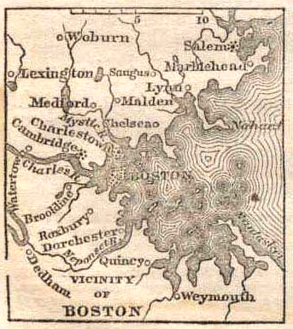 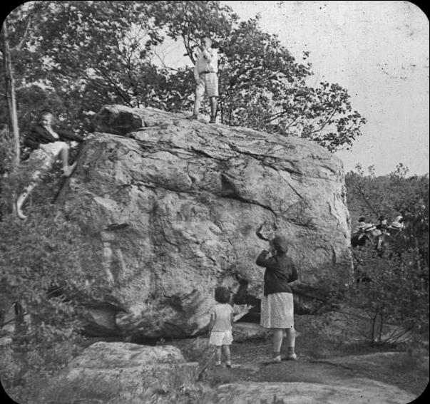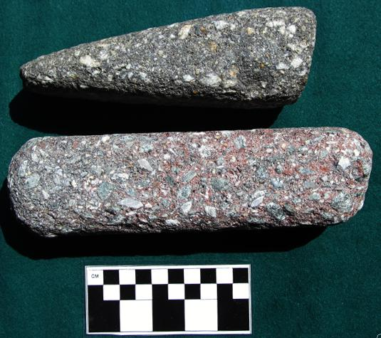

Fig. 1, left: 1849 map of Boston Bay area. Fig. 2, middle: Pulpit Rock, Roxbury, Massachusetts, from a 1912 photo by Eliot C. French, courtesy of the Canton Historical Society, showing the flat, slanted platform where the Rev. John Eliot preached to Native Americans in the 1640's. Fig. 3, right, two Permian conglomerate blocks found in Marblehead, Massachusetts.

References:

Billings, M.P. 1976. *Geology of the Boston Basin.* In: J.W. Skehan and D.P. Murray, eds. Studies in New England Geology. Memoir no. 46. Boulder, Colorado: Geological Society of America, pp. 5-30.

Cogley, Richard W. 1999. *John Eliot's Mission to the Indians before King Philip's War*. Cambridge: Harvard University Press.

McFarland, Philip. 2004. *Hawthorne in Concord*. New York: Grove Press.

Mansfield, G. R., 1906, *The Origin and Structure of the Roxbury Conglomerate.* Bulletin of the Museum of Comparative Zoology at Harvard College. no. XLIX, p. 180